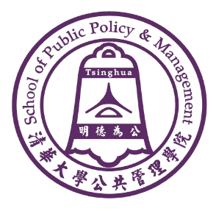
LIBRARY READER’S GUIDE (FALL, 2026)

Overview of SPPM Library
The SPPM library was officially open for service in October 2000 with donations from well-known Hong Kong lawyers, Mr Yu Ruichao and Ms Zheng Nizhi. Through continuing efforts, the library has established a modest but adequate collection of printed and electronic materials in various disciplines related to public policy and management. It aims at providing high-quality, efficient, and timely services for teaching and academic research.
At present, the library covers an area of more than 400 square meters which provides 43 seats. Its collections include over 20,600 English books, 52,100 Chinese books, 6500 graduate dissertations and 121 Chinese and English newspapers and periodicals. The database collects statistical yearbooks of all provinces, autonomous regions, municipalities as well as teaching materials, research reports and internal documents.
The library also receives donation books and professional literature from the World Bank, the Asia Foundation, the Kennedy School of Government and other long term partners. At the same time, the library has benefited from donations from individuals such as Prof. Don E. Kash of George Mason University, Prof. Masahiko Aoki of Stanford University, and many other faculty and alumni.

Opening Hours
Monday to Friday: 8:30 am-9:00 pm，Saturday: 8:30 am-5:00 pm.
(For holidays and vacations, please refer to the special notice.)

Circulation Rules
1. Registration on the reception

2. Loan Quotas: 20 copies in all

3. Chinese & English Books: loan periods 2 months

4. Periodical, Dissertation, Reference Book: loan periods 10 days

5. Stock books are only for in-library use
Online Service
- This is the Homepage of SPPM. Log in the Website of SPPM：https://www.sppm.tsinghua.edu.cn/
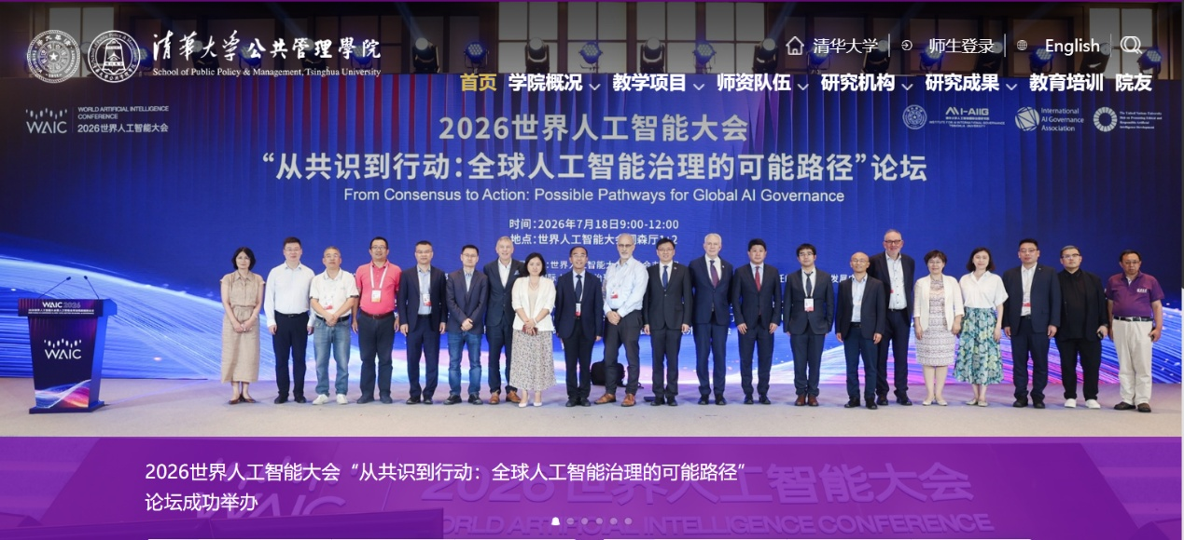

2. Please scroll down! Then, in the right corner of the page, Click the “library”.

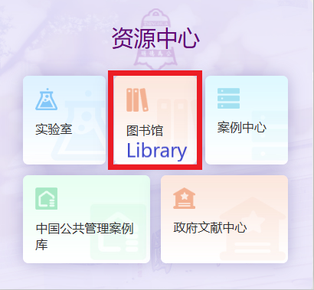
3. Website of SPPM library : https://www.sppm.tsinghua.edu.cn/tsg.htm,
On this page, you can see the English E-Journal content.

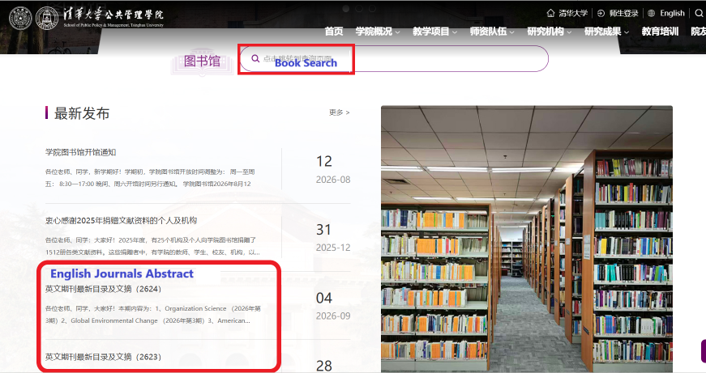

4. Please scroll down! Then, in the right corner of the page, Click the “reader services”.
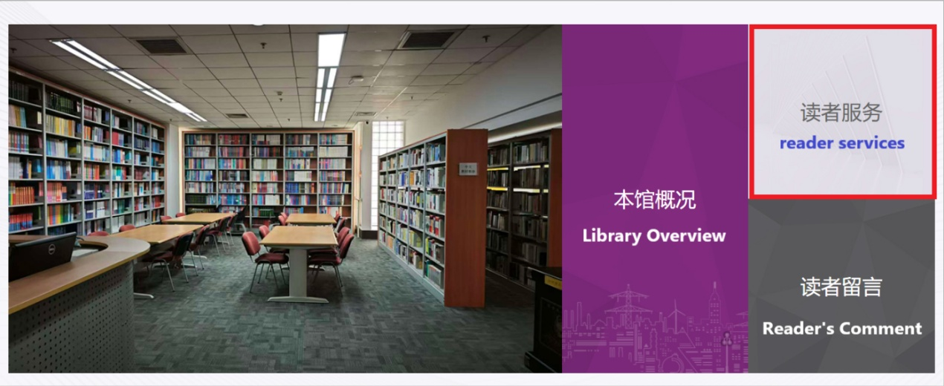

5. On this page, you can also see the catalogue of English Journals.
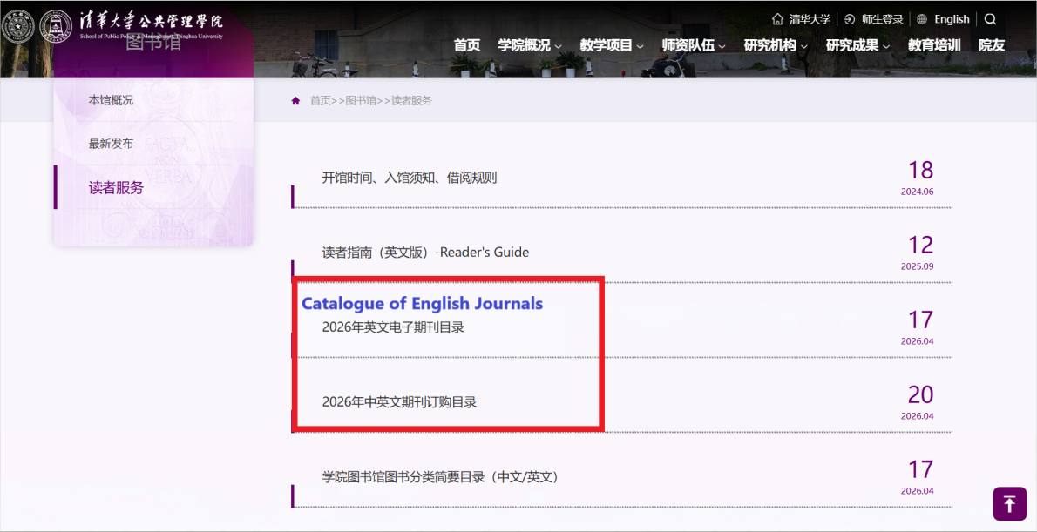

6. Then Return to the homepage of the library，Click “Book Search”.

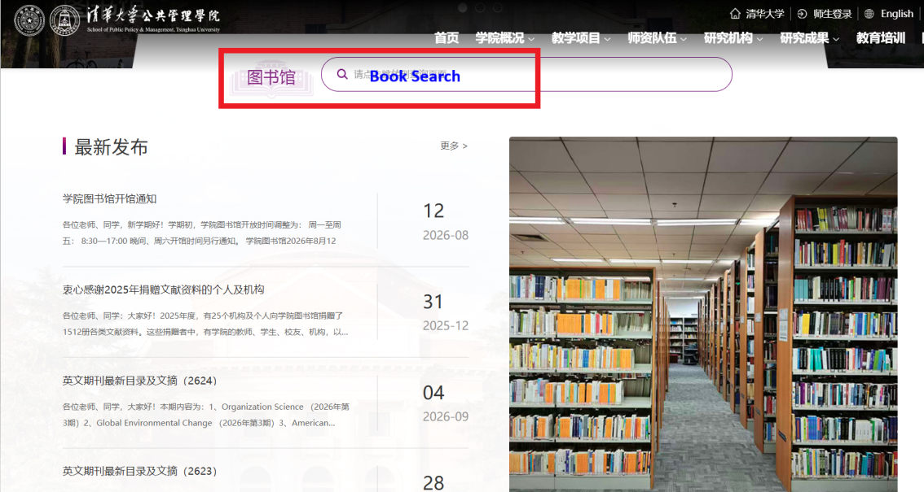

7. Library Catalog:
https://lib.sppm.tsinghua.edu.cn/WebOPAC/search_simpleSearchView
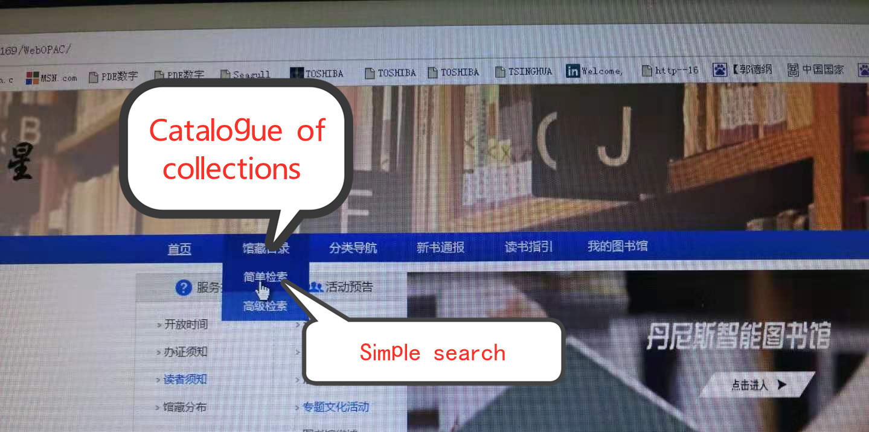

8. Input Title or Key Words:
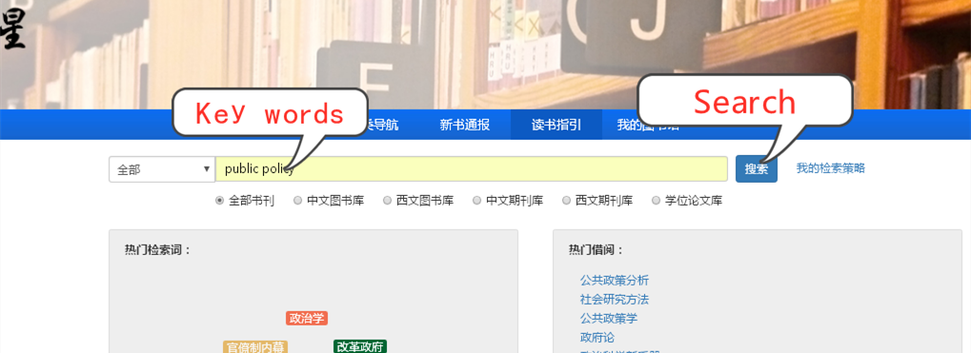

Or Input the auther’s name:
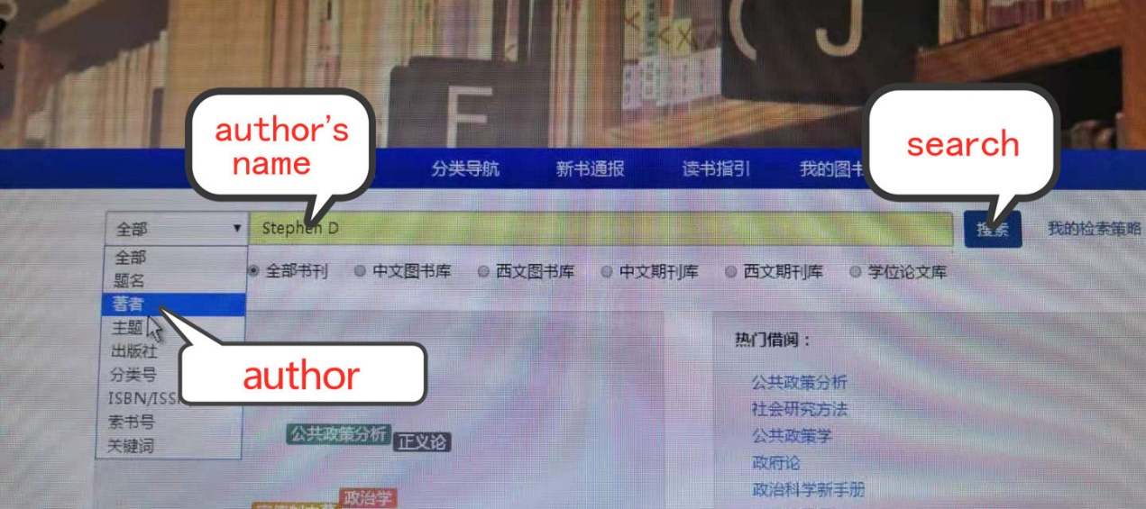
9. Please take note of the“Call Number”and “Location”，and find the book on corresponding shelf. Stock book is not available for borrowing.
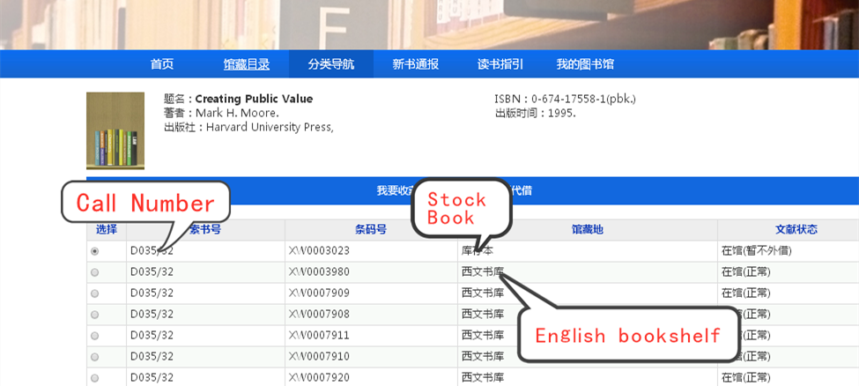

Contact Us
If you have any problem or advice, please contact us at:
Telephone：62788956
Email: lib-sppm@tsinghua.edu.cn
SPPM Library Public Account
